1. Executive Summary
The objective of this project is to develop a robust, production-ready Library Management System (LMS). After conducting a thorough review of open-source solutions, we have selected an existing codebase that serves as a solid foundational architecture. This proposal outlines our plan to adopt this system and significantly expand its capabilities by implementing 21 new critical features, focusing on security, automation, user experience, and DevOps best practices.

2. Base System Selection
We have identified the following GitHub repository as our base implementation:
- Repository: https://github.com/alvinmdj/library-management-system
- Current State: The system functions as a basic lending platform with essential CRUD operations.
To visualize the system's high-level interactions, the following Context Diagram (DFD Level 0) illustrates how external entities (Guest, Member, Admin) interact with the core system.
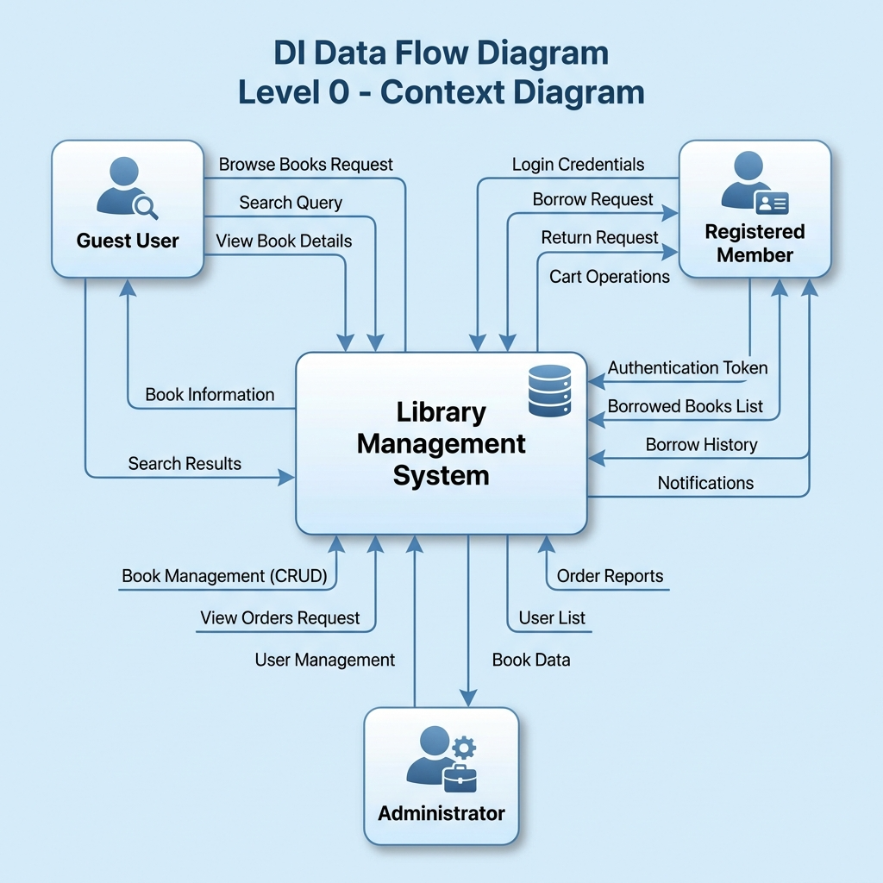
Figure 1: Data Flow Diagram - Level 0 (Context Diagram)

2.1 System Architecture & Data Structure
The application is built upon a relational database structure. The Entity Relationship Diagram (ERD) below details the four main entities: USER, BOOK, CART, and BORROW_HISTORY, and their relationships.
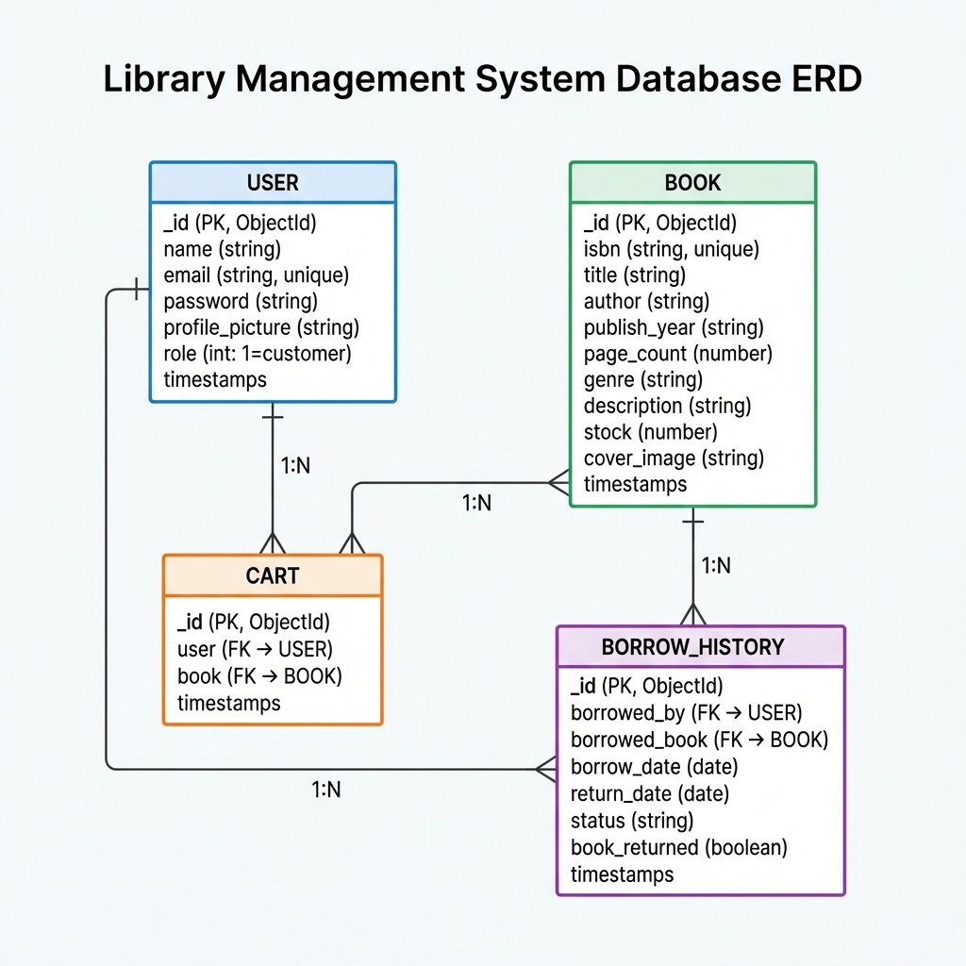
Figure 2: Entity Relationship Diagram (ERD)

Entity | Key Attributes | Relationships
USER | _id, name, email, password, role | Has many Cart items, Has many BorrowHistory
BOOK | _id, isbn, title, author, genre, stock | Used in Cart, Referenced in BorrowHistory
CART | _id, user (FK), book (FK) | Belongs to User, Contains Book
BORROW_HISTORY | _id, borrowed_by (FK), borrowed_book (FK), status | Belongs to User, References Book

3. Existing Features
The current codebase provides the following functionalities which we have verified. The Use Case Diagram below provides an overview of available actions for each user role.
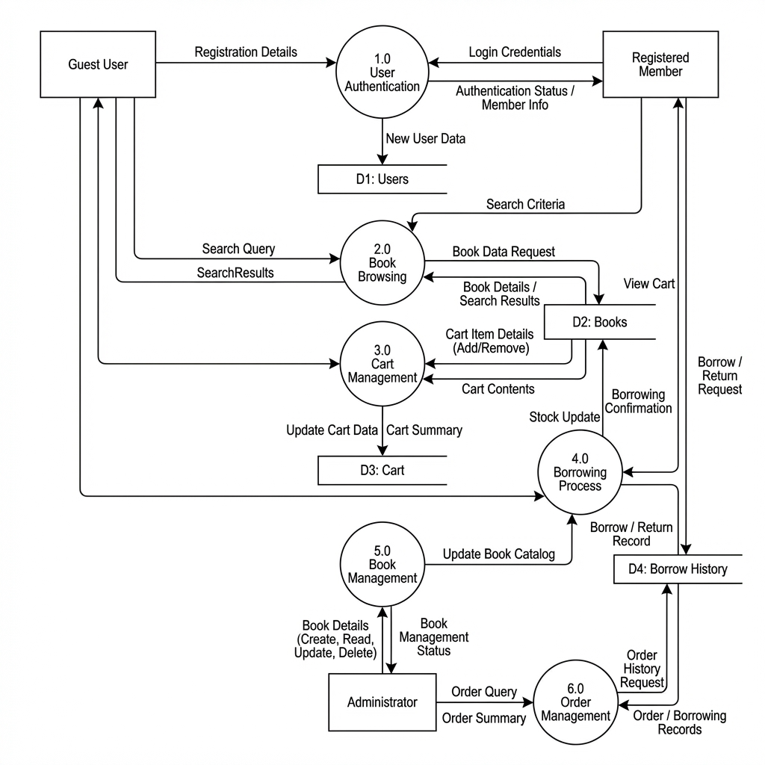
Figure 3: Data Flow Diagram Level 1 - Detailed Process View

3.1 Public Features (No Login Required)
- Homepage: View popular books and recently added books.
- Browse All Books: Paginated list of all books with sorting.
- Search Books: Search books by title.
- Filter by Genre: Browse books by 14 available genres.
- View Book Details: See book information (ISBN, author, pages, description).

3.2 User Features (Login Required)
- User Registration: Create account with name, email, password.
- User Login: JWT-based authentication with 7-day session.
- Profile Management: View and edit profile, upload profile picture.
- Shopping Cart: Add books to cart, remove items.

Borrowing & Returning Process
- Borrow Books: Borrow books from cart with date selection.
- Inventory: View currently borrowed books.
- Return Books: Return borrowed books before/at due date.
- Borrow History: View complete borrowing history with status.
The logic for these core operations is detailed in the flowcharts below:
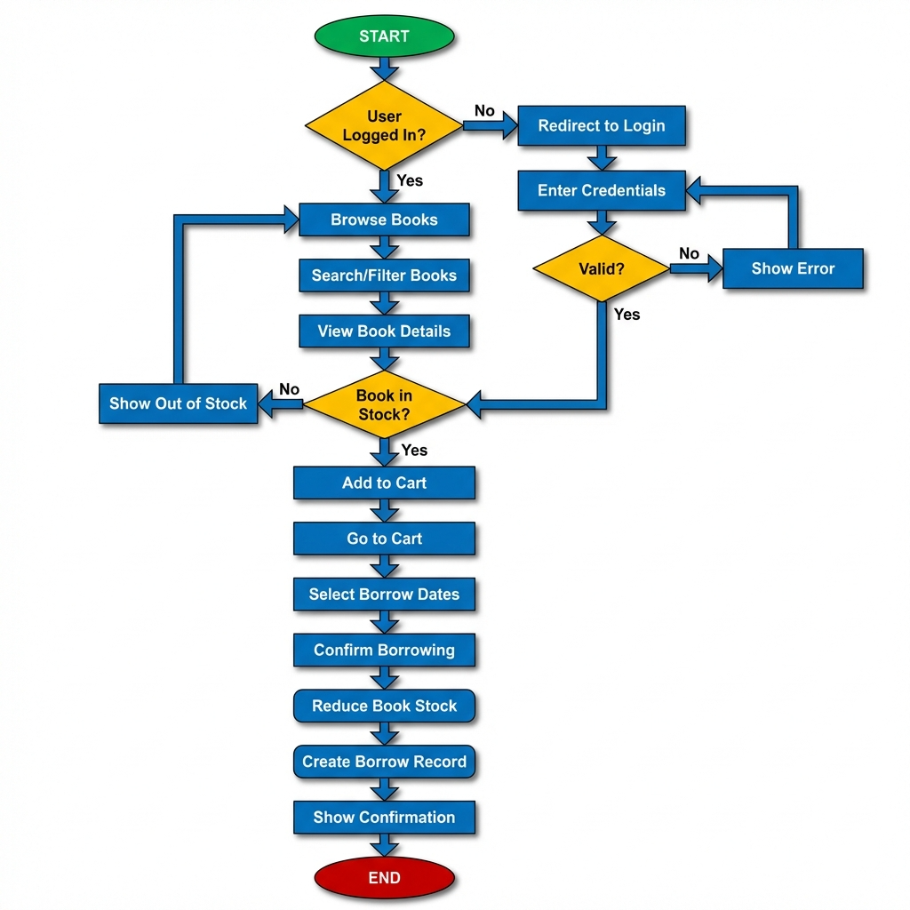
Figure 4: Book Borrowing Process Flow
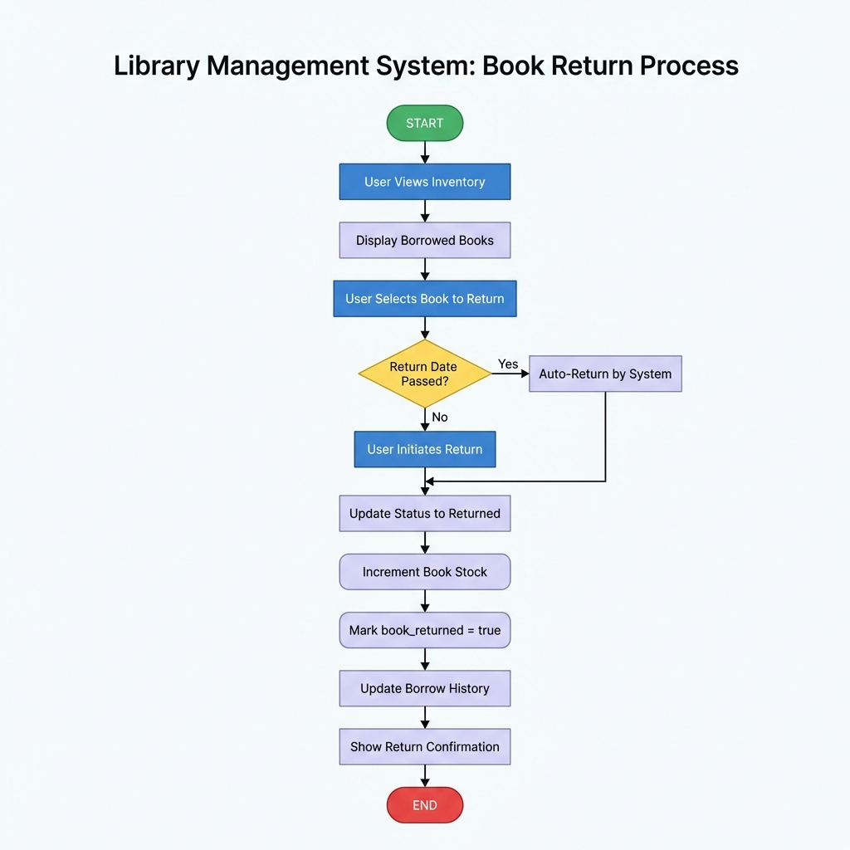
Figure 5: Book Return Process Flow

3.3 Admin Features (Admin Login Required)
- Admin Dashboard: Access to all administrative functions.
- Search Books: Search by title or ISBN.
- View All Orders: See all borrow records from all users.
- View All Users: List all registered users.

Book Management
- Add Books: Add new books with cover images.
- Edit Books: Update book information.
- Delete Books: Remove books from the system.
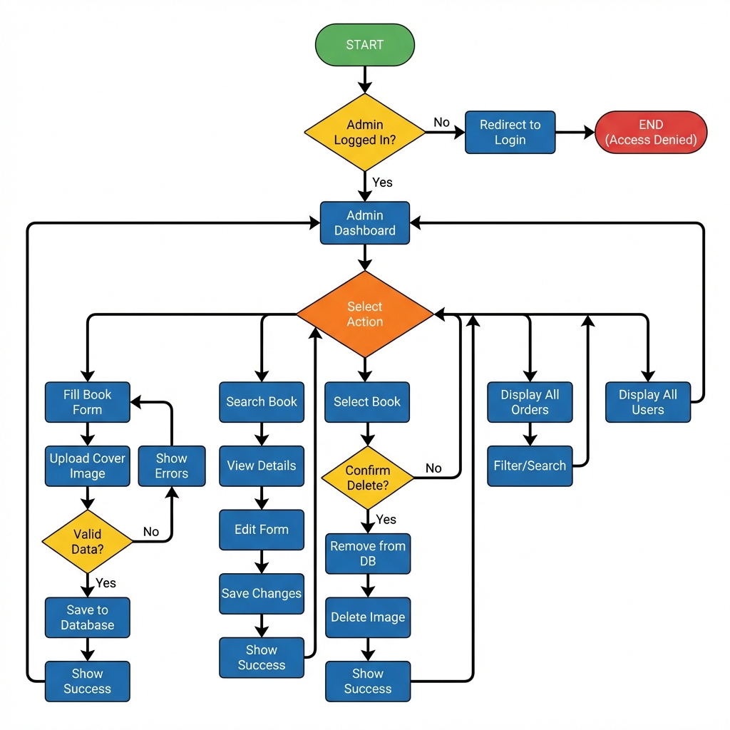
Figure 6: Admin Book Management Flow

4. Proposed Feature Expansion
To transform this basic system into a comprehensive LMS, we propose implementing the following enhancements. These features address security gaps, administrative needs, and modern deployment standards.

Project Feature List
# | Category | Feature | Description
1 | Security | Password Reset | Email-based password recovery
2 |  | Email Verification | Verify email on registration
3 | Book Mgmt | Book Reviews/Ratings | Users can rate and review books
4 |  | Book Reservations | Reserve out-of-stock books
6 |  | Book Categories | Multiple categories per book
7 |  | QR Code for Books | Generate QR codes for books
8 |  | Bulk Book Import | Import books from CSV/Excel
9 | UX | Wishlist | Save books for later
10 |  | Notifications | Email due date reminders
11 |  | Social Login | Google/Facebook authentication
12 |  | Dark Mode | Theme toggle
14 | Admin | Analytics Dashboard | Charts for borrowing trends
15 |  | Fine Management | Late return penalties
17 |  | Audit Logs | Track admin actions
18 |  | Book Reports | Export borrowing data
19 | DevOps | CI/CD Pipeline | GitHub Actions auto-deploy to Cloud
20 |  | Docker Support | Containerize the application
21 |  | Barcode Scanner | Scan book ISBN

5. Conclusion
By building upon the selected repository and integrating the workflows detailed in the system diagrams above, we can bypass the initial boilerplate setup. We will focus our efforts on high-value features such as CI/CD integration, Security, and Analytics. This approach ensures we deliver a sophisticated, feature-rich application within the project timeline.

